KSR INSTITUTE FOR ENGINEERING AND TECHNOLOGY

TIRUCHENGODE

FULL STACK DEVELOPMENT

**NAME : SHOBNA SAMUKTHA RAJ S**

**DEPT : B.E-(CSE)**

**YEAR : IV**

**DATE : 06.08.2024**

**1.INSERTION IN EMPLOYEE MANAGEMENT SYSTEM :**

**OUTPUT**

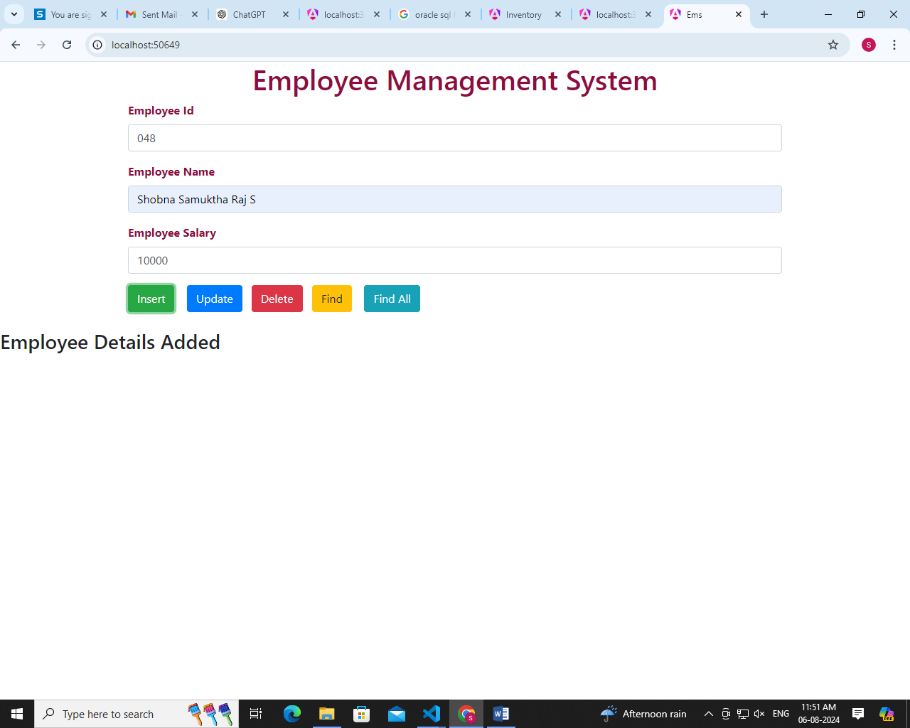

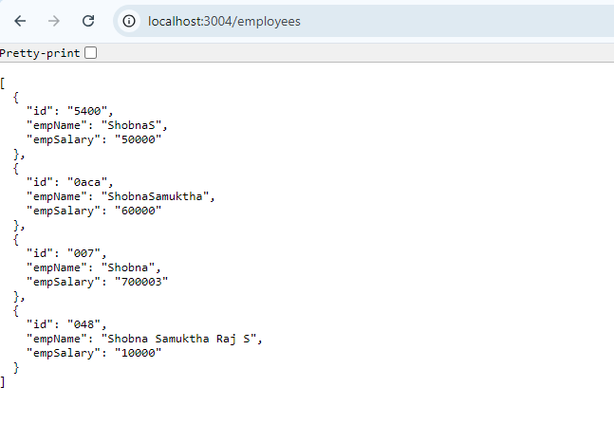

**2. UPDATION IN EMPLOYEE MANAGEMENT SYSTEM**

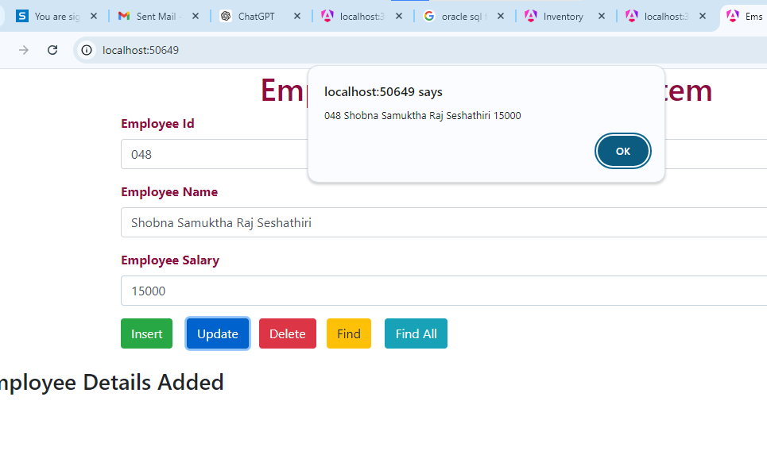

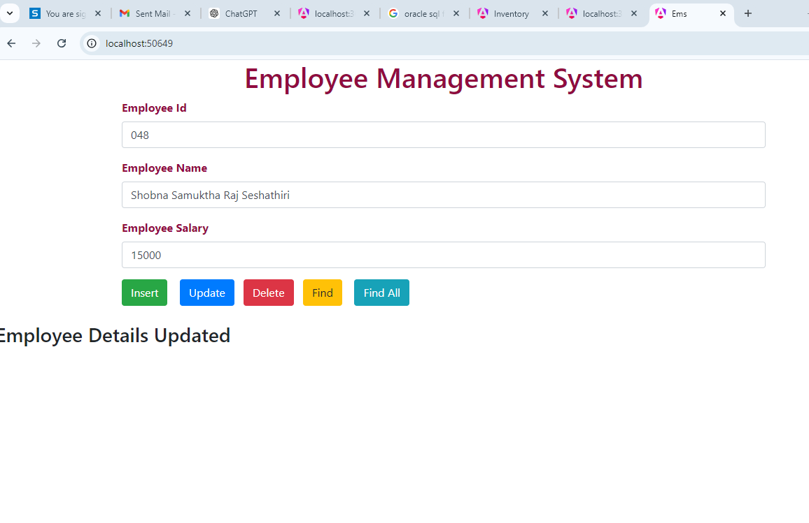

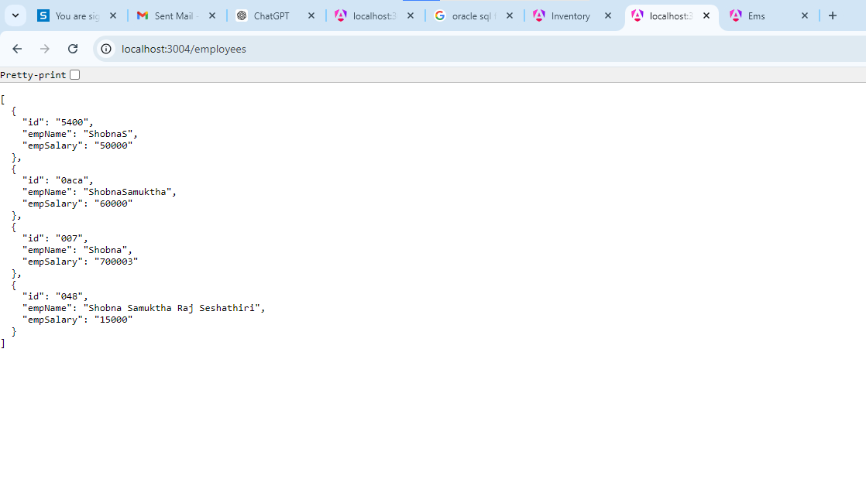

**3.DELETION IN EMPLOYEE MANAGEMENT SYSTEM**

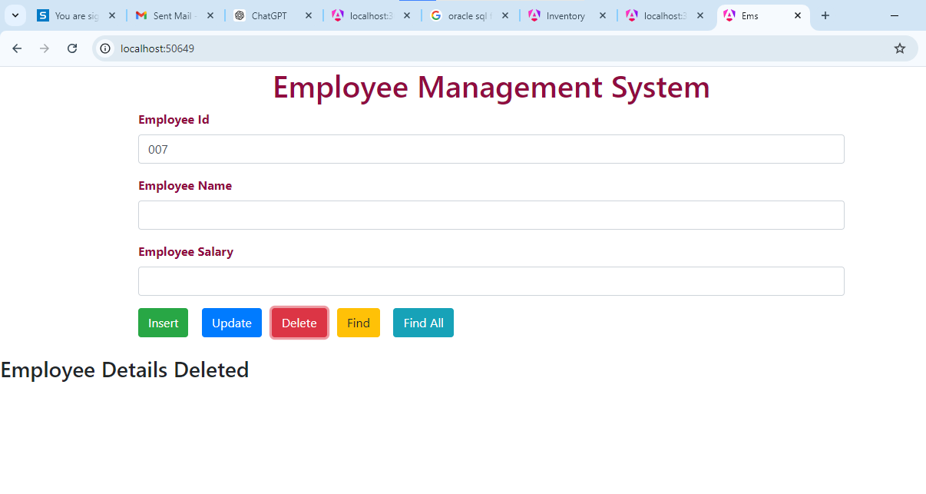

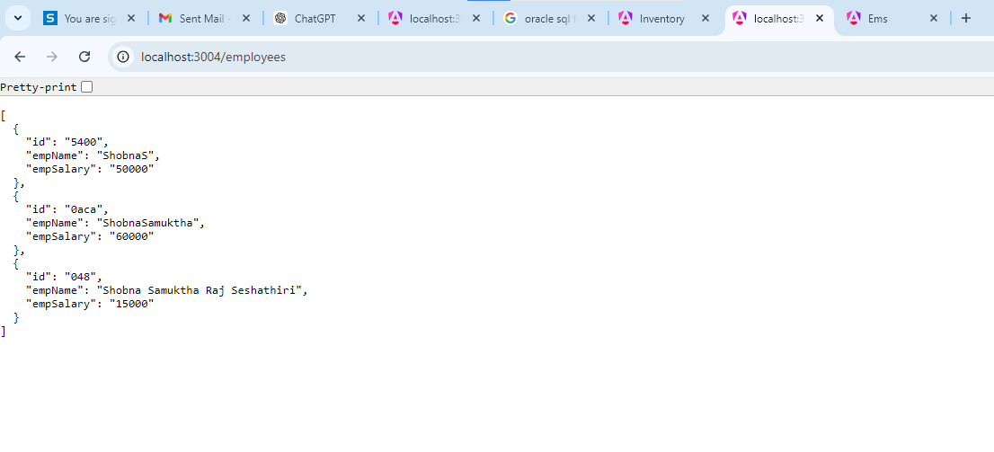

**4. FIND IN EMPLOYEE MANAGEMENT SYSTEM**

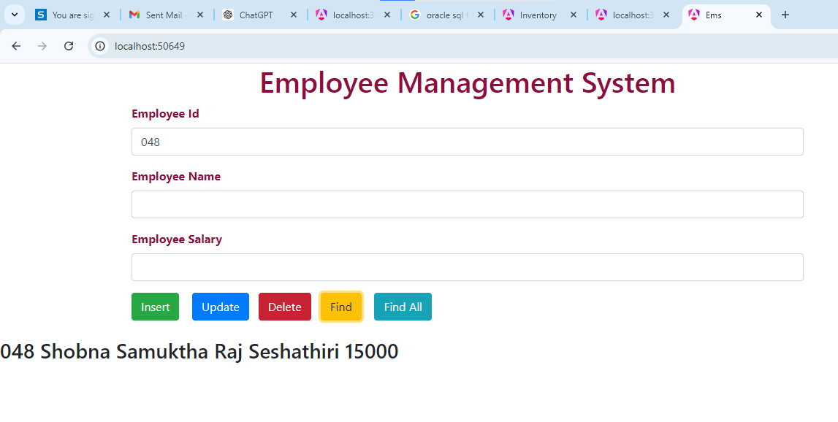

**5. FINDALL IN EMPLOYEE MANAGEMENT**

